MedReview Project Report
A Proof-Verified Review Platform for Hospitals, Doctors & Medical Services
Team: Group 05 - THREE ALPHA
Members: Raihan Islam (C243212), Obaidur Rahim (C243228), Tofayel Ahmmed (C243236)
Repository: github.com/Raihans-code/Med-review
Stack: Node.js, Express 5, PostgreSQL, Prisma, Zod

Executive Summary
MedReview is a relational database-backed review and directory platform designed to establish trust in healthcare services by providing proof-verified ratings for hospitals, doctors, and medical services. The project addresses the prevalent trust deficit in online healthcare reviews by requiring verifiable evidence—such as medical bills, appointment numbers, or supporting documents—before feedback is approved and published. The system utilizes a normalized PostgreSQL database schema managed through Prisma ORM and exposes functionality via an Express.js/Node.js REST API. User authentication, input validation with Zod, and role-based access control separate regular patient privileges from administrative oversight. The relational schema comprises 12 core models linked through primary keys, foreign keys, unique constraints, and enums to maintain referential integrity and support detailed healthcare analytics.
1. Introduction
- Trust Deficit in Healthcare: Patients frequently struggle to find reliable healthcare providers due to unverified, anonymous, or manipulated reviews across traditional directories.
- Proof-Verified Feedback: Every submitted review requires evidence (e.g., appointment number, bill, or file upload) before undergoing admin moderation.
- Multi-Dimensional Metrics: Instead of a single flat star rating, the platform collects distinct feedback on staff behavior, punctuality, doctor knowledge, and bedside manner.
- Unified Provider Directory: Integrates hospitals, doctors, specialties, and specialized medical services within a single relational system.
- Target Beneficiaries: Patients seeking verified medical care, platform administrators moderating content, and healthcare organizations aiming for authentic feedback.
2. Problem Identification
- No Proof of Visit: Anonymous and unverified feedback with no proof that an actual consultation occurred.
- Manipulated Ratings: Fake positive reviews falsely elevate clinics while unverified negative reviews damage practitioner reputations.
- One Flat Rating Scale: Standard 5-star scales fail to distinguish between operational efficiency (e.g., wait time) and clinical quality (e.g., bedside manner).
- Dynamic Affiliations: Doctors practice across multiple institutions; static directories fail to capture complex doctor-hospital relationships.
- Weak Moderation & Privacy Risks: Absence of structured review pipelines risks publishing offensive content or leaking sensitive patient data.
- Lack of Auditability: Absence of administrative logging hinders compliance and system security tracking.
3. Objectives
3.1 General Objectives
- Build patient trust using proof-verified submissions and transparent multi-dimensional rating metrics.
- Maintain data integrity across dynamic doctor, hospital, specialty, and service entity relationships.
- Enforce security, HIPAA-style privacy considerations, and administrative audit logging.
3.2 Administrator Objectives
- Verify and moderate submitted reviews by approving or rejecting submissions with internal notes.
- Manage directory entities including hospitals, doctors, specialties, medical services, and doctor-hospital affiliations.
- Review user reports concerning spam, offensive language, or HIPAA violations.
- Monitor security events and system actions via structured system logs.
3.3 Patient / User Objectives
- Search and browse verified providers filtered by specialty or geographic city.
- Submit multi-dimensional ratings backed by mandatory proof (bills, appointment IDs, or documents).
- Save/bookmark preferred providers for future access.
- Vote on the helpfulness of published reviews and flag non-compliant or fraudulent submissions.
4. Features
AREA | KEY FEATURES
Authentication & Users | JWT-based authentication, password hashing with bcrypt, role management (USER, ADMIN).
Provider Directory | CRUD operations for Hospitals, Doctors, Specialties, and Medical Services.
Affiliation Management | Dynamic Doctor-Hospital junction mappings supporting primary institution designations.
Proof-Backed Reviews | Multi-category ratings (staff, punctuality, knowledge, bedside manner) with mandatory file/ID proof.
Moderation Engine | Pending review queue for admins with approve/reject actions and logging notes.
User Engagement | Helpfulness voting (HELPFUL, NOT_HELPFUL), community content reporting, and saved listings.
Security & Auditing | Zod payload validation, role middleware, and masked IP address logging in SystemLog.

5. System Design Decisions & Edge Case Solutions
- Pending Status by Default: Every new review defaults to PENDING status to prevent unmoderated or fake feedback from going live.
- Spam Prevention in Voting: Unique compound constraint on [reviewId, userId] within the ReviewVote model prevents duplicate votes.
- Flexible Target Entities: Polymorphic-like optional foreign keys in Review allow feedback to directly target a Hospital, Doctor, or Medical Service.
- Dynamic Doctor Affiliations: Dedicated DoctorAffiliation join table with an isPrimary flag tracks doctors practicing at multiple hospitals.
- Flexible Sub-Ratings: Staff behavior and punctuality ratings are mandatory, while clinical metrics (knowledge, bedside manner) remain optional for general service reviews.
- Privacy-Conscious Logging: SystemLog.ipAddress stores IP addresses in a masked, truncated format to uphold patient privacy standards.
6. System Workflow Diagram
Figure 1 illustrates the MedReview architectural and review moderation workflow from patient submission to public listing or administrative rejection:
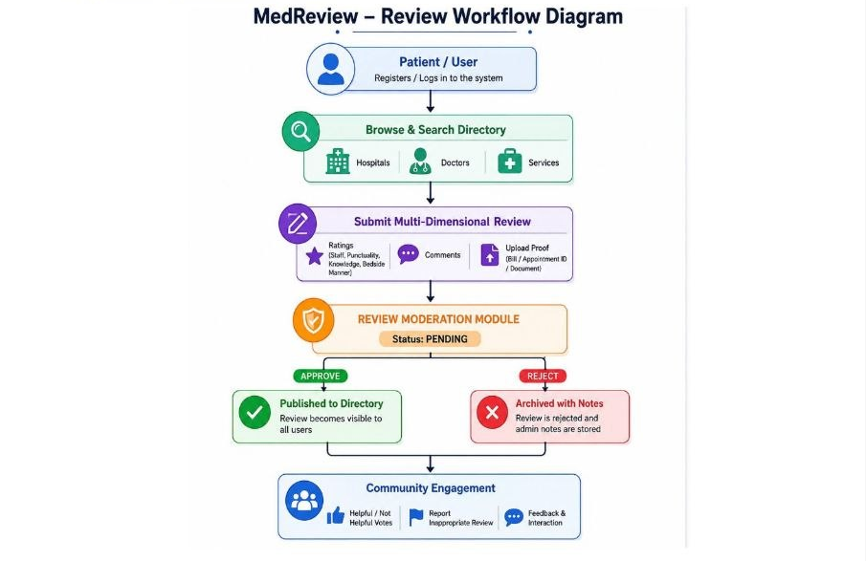
7. System Architecture
LAYER | TECHNOLOGY / RESPONSIBILITY
Client/Consumer | Web/Mobile Clients or API Consumers sending HTTP requests.
Authentication & Validation | JWT Auth Middleware, bcrypt password hashing, Zod schema validation.
Application Layer | Node.js with Express.js 5 handling routes, business logic, and controllers.
Data Access Layer | Prisma ORM with @prisma/adapter-pg driver.
Database Layer | Relational PostgreSQL database environment.
Development Tools | Git, GitHub, TypeScript Types, dotenv, nodemon.

8. Entity Relationship Diagram (ERD) Structure
The core database architecture consists of 12 interconnected relational tables:

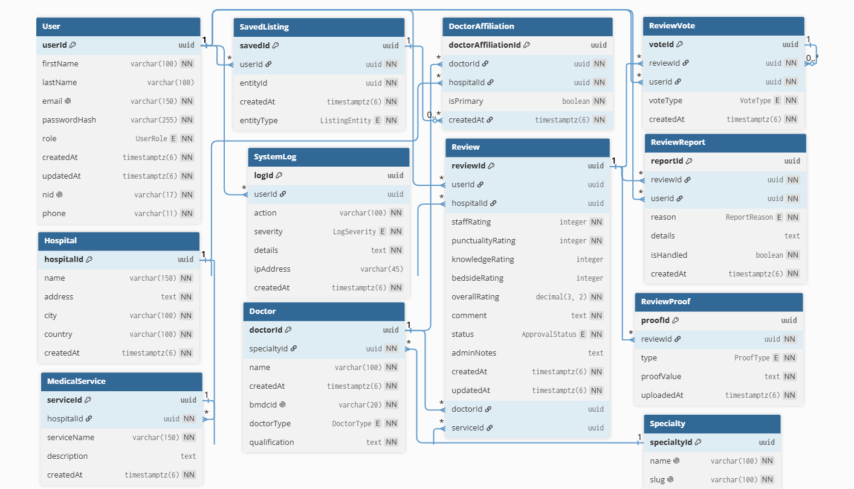

9. Database Schema & Enumerations
TABLE | PURPOSE | KEY RELATIONS
User | User profiles and credentials | 1:M Review, SavedListing, ReviewVote, ReviewReport
Hospital | Hospital directory profiles | 1:M DoctorAffiliation, MedicalService, Review
Doctor | Practitioner profiles | M:1 Specialty, 1:M DoctorAffiliation, Review
Specialty | Medical domain classifications | 1:M Doctor
MedicalService | Specific treatments/services | M:1 Hospital, 1:M Review
DoctorAffiliation | Doctor-Hospital assignments | M:1 Doctor, Hospital
Review | Core review entry | M:1 User, Optional Target, 1:M ReviewProof
ReviewProof | Verification proof files/IDs | M:1 Review
ReviewReport | Flagged content queue | M:1 Review, User
ReviewVote | Review helpfulness tracking | M:1 Review, User
SavedListing | User bookmark list | M:1 User, Optional provider foreign key
SystemLog | System activity and audit trail | Optional M:1 User

9.1 Enumerations
ENUM NAME | ALLOWED VALUES
UserRole | USER, ADMIN
ProofType | BILL, APPOINTMENT_NUMBER, FILE_UPLOAD
ApprovalStatus | PENDING, APPROVED, REJECTED
ReportReason | SPAM, OFFENSIVE, HIPAA_VIOLATION, FALSE_INFO, OTHER
VoteType | HELPFUL, NOT_HELPFUL
LogSeverity | INFO, WARNING, ERROR, SECURITY

10. Requirement Tools
CATEGORY | TOOLS / TECHNOLOGIES
Runtime & Framework | Node.js, Express.js 5
Language & Types | JavaScript / TypeScript types
Database & ORM | PostgreSQL, Prisma ORM (@prisma/adapter-pg)
Security & Validation | JWT (JSON Web Tokens), bcrypt, Zod schema validator
Development Utilities | dotenv, nodemon, Git, GitHub

11. Implementation Steps
1. Conducted domain analysis on healthcare review trust deficits.
2. Designed normalized relational schema containing 12 entities.
3. Implemented Prisma Schema and connected PostgreSQL instance via Prisma Client.
4. Built authentication endpoints with bcrypt password hashing and JWT token management.
5. Created authorization middleware (authMiddleware, adminMiddleware) for access control.
6. Developed REST API routes/controllers for CRUD operations on directory entities.
7. Built the proof-backed review engine and admin moderation workflow.
8. Implemented user interaction features (SavedListings, ReviewVotes, and Content Reports).
9. Populated database with test seed data and verified role-based restrictions.
12. API Design & Sample Endpoints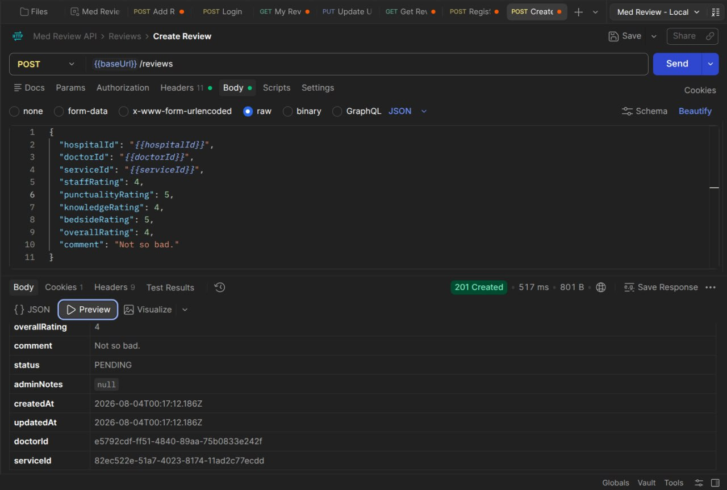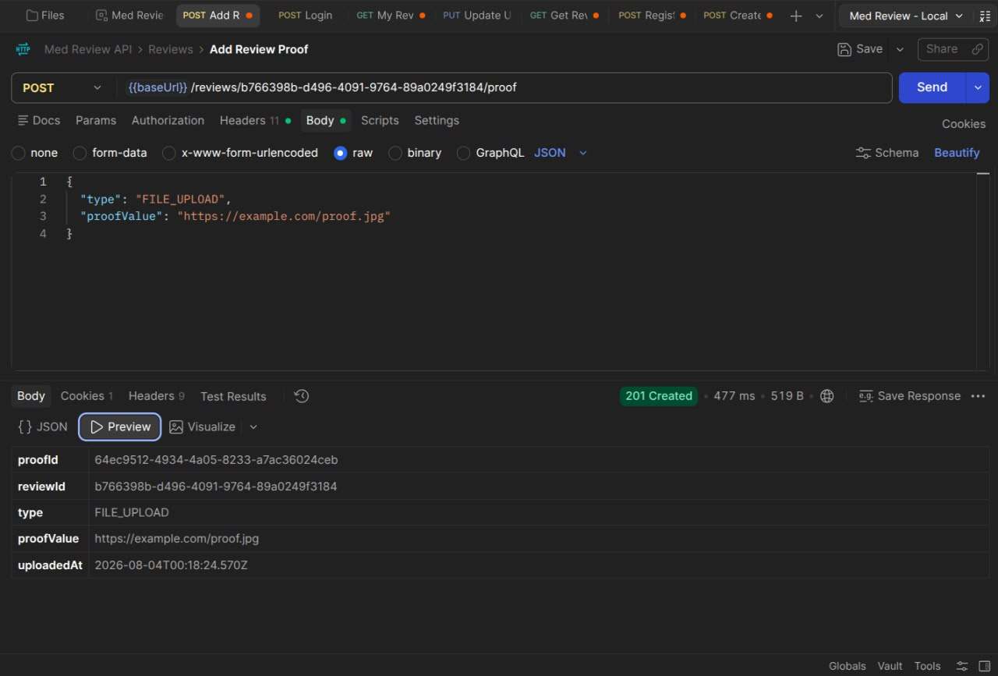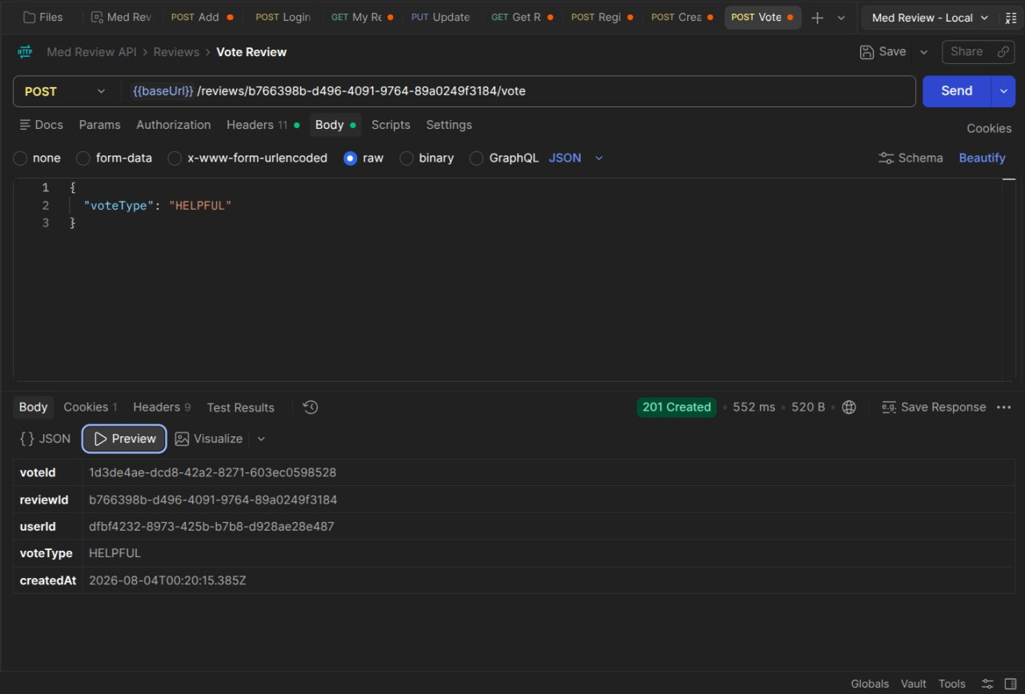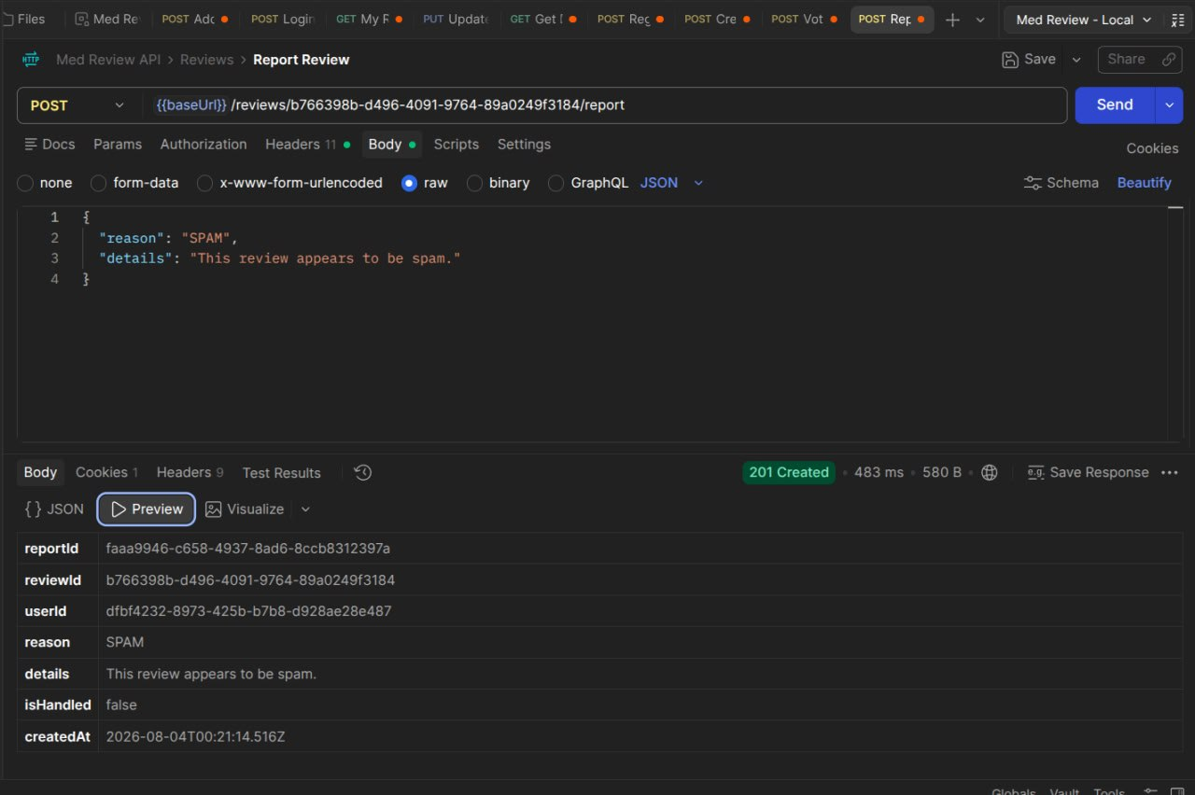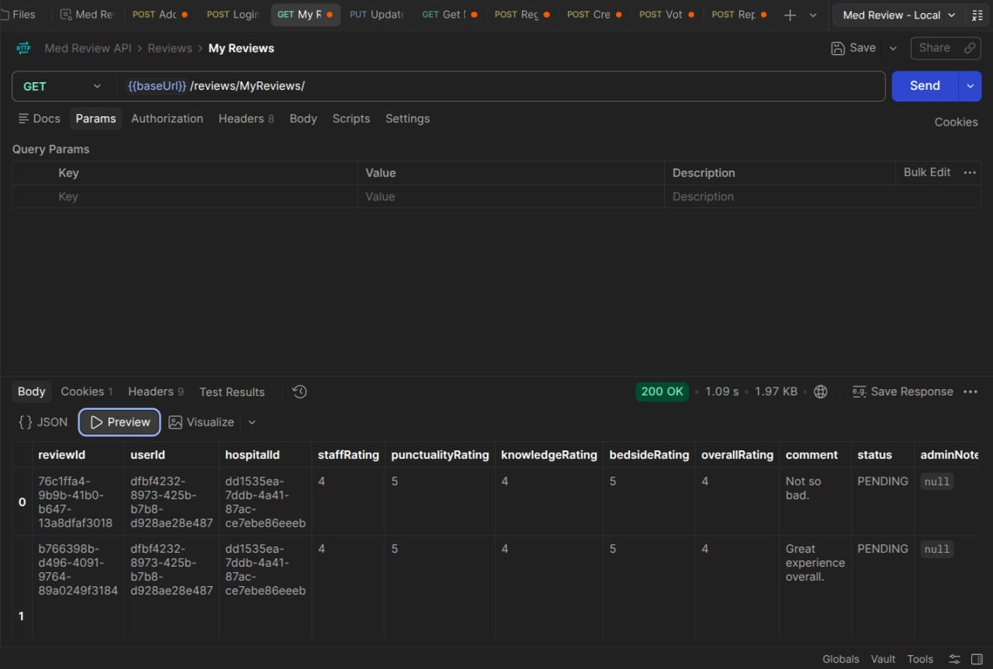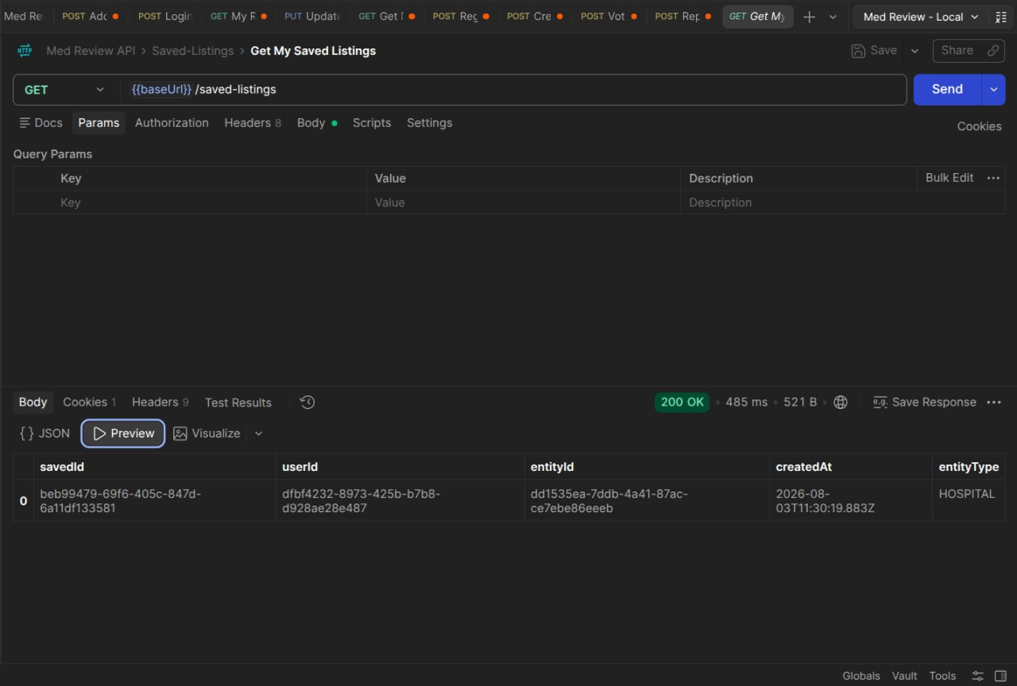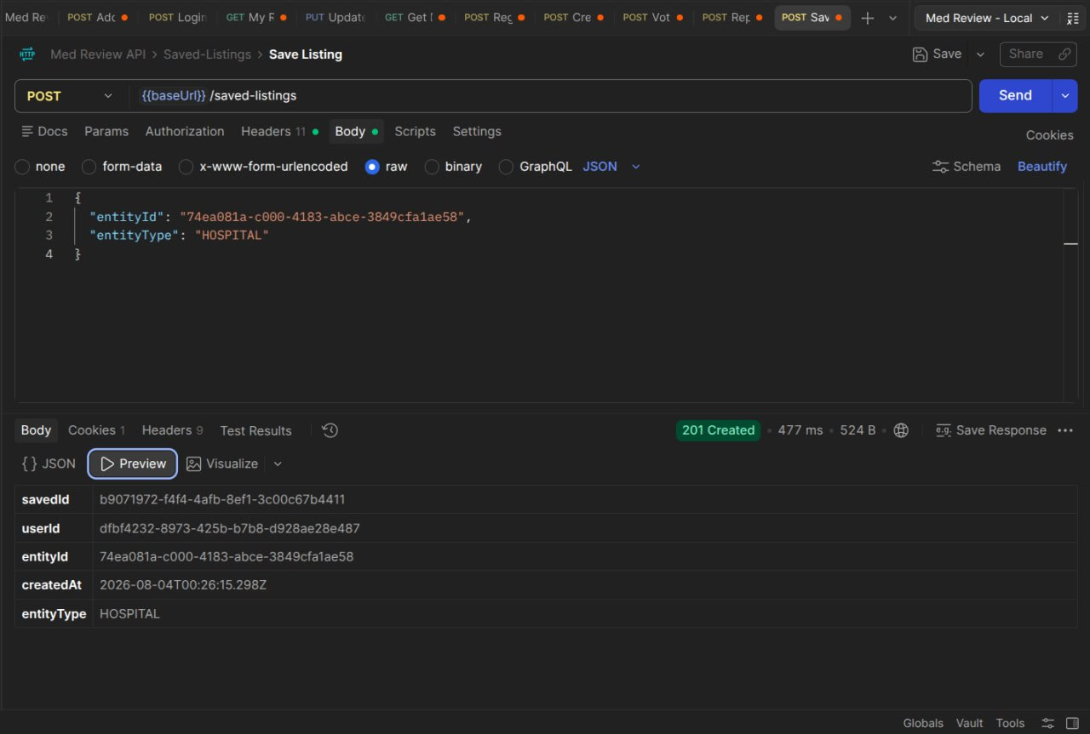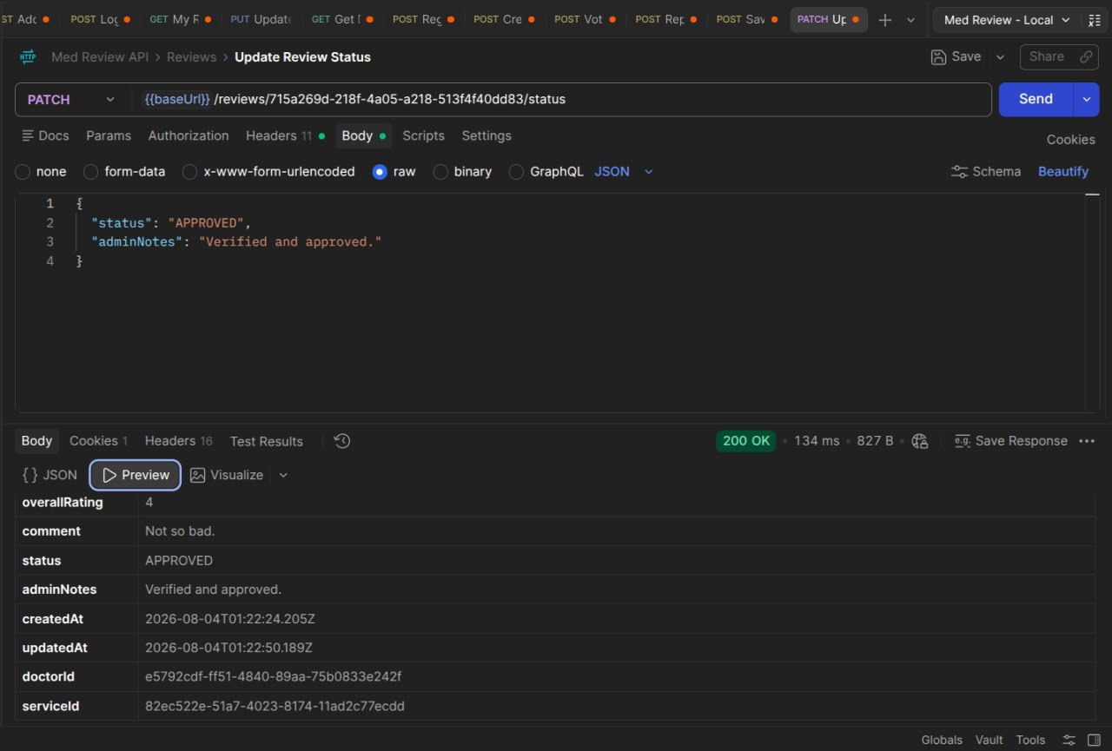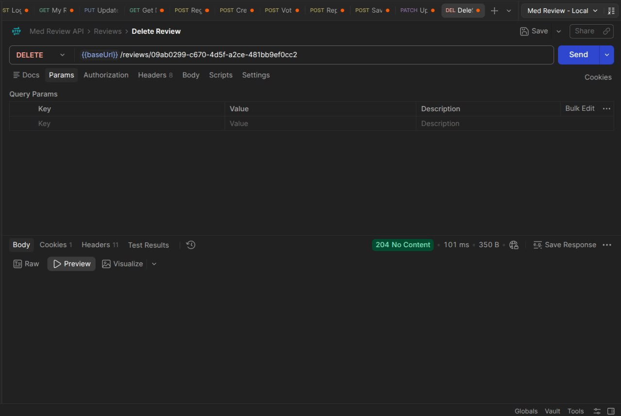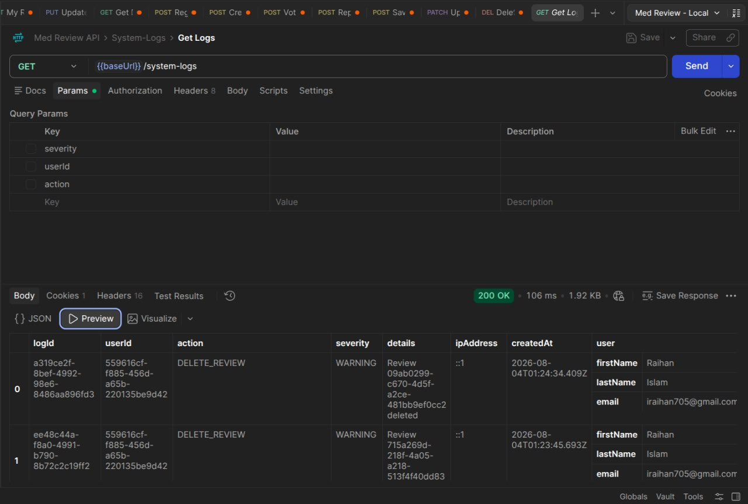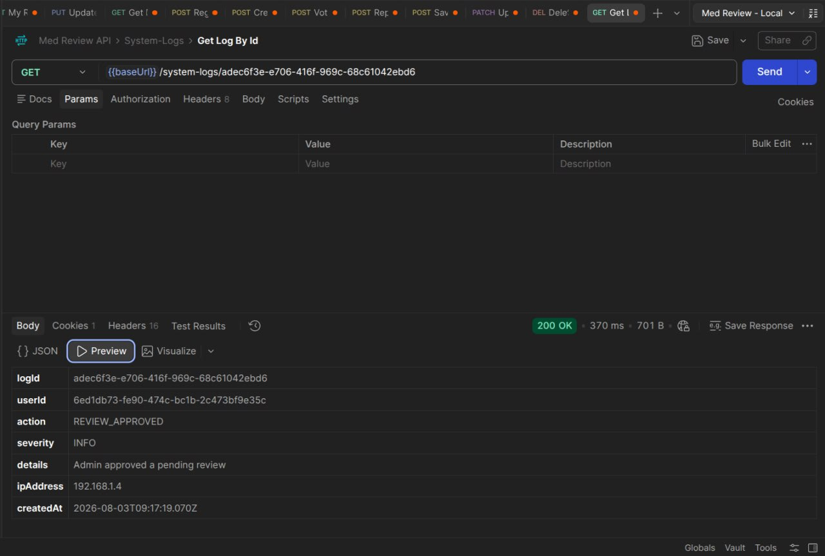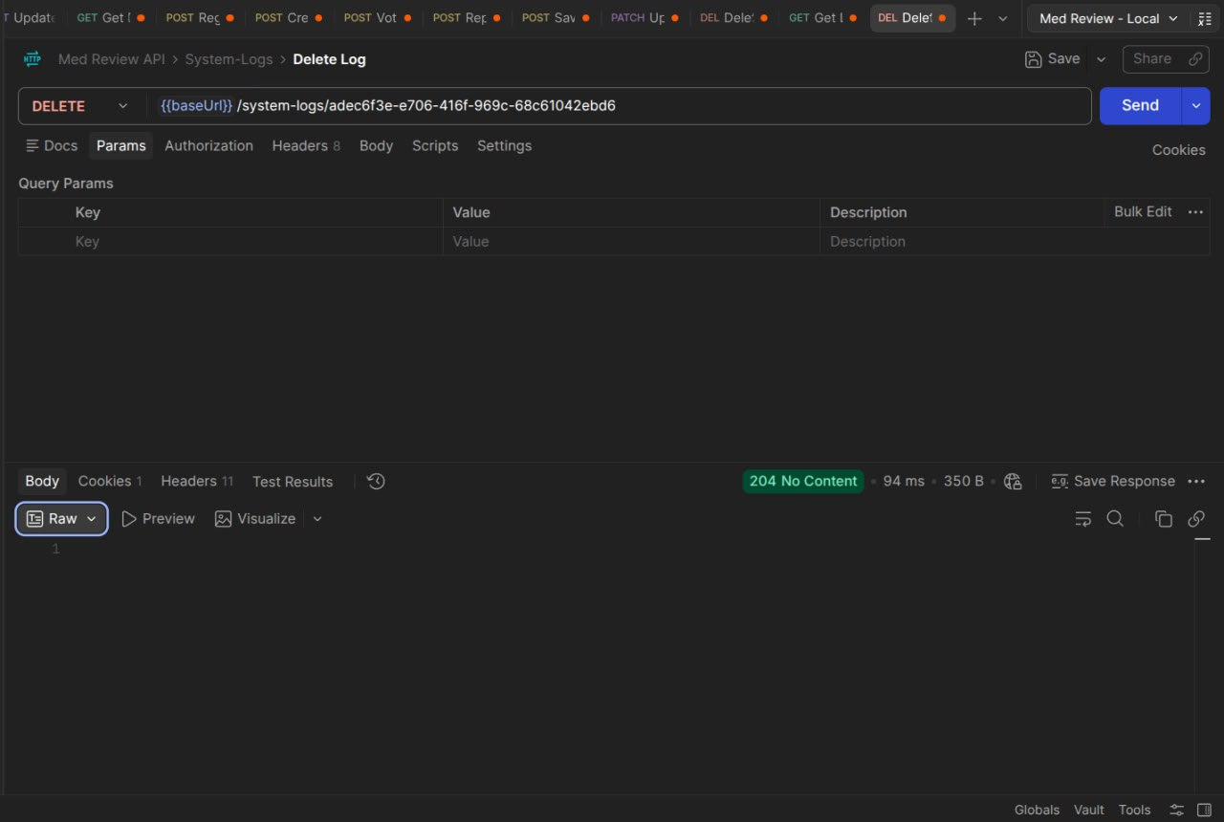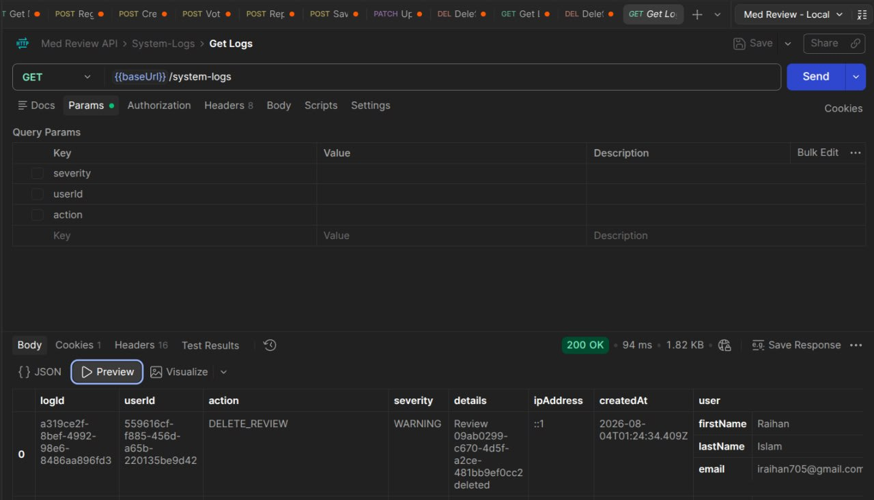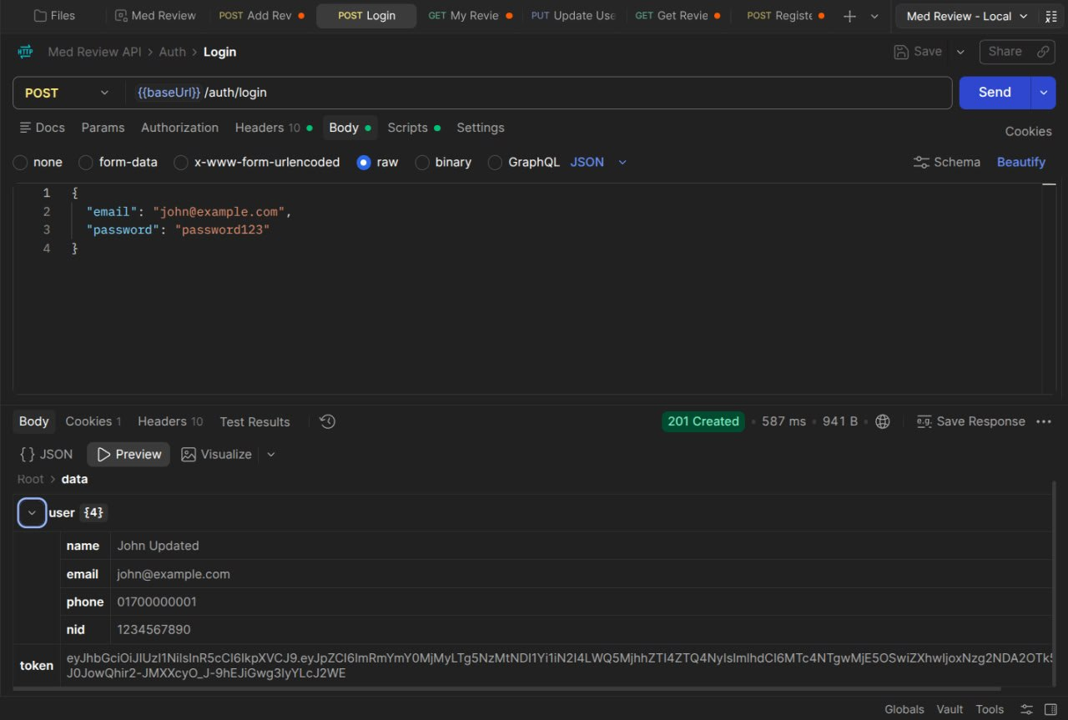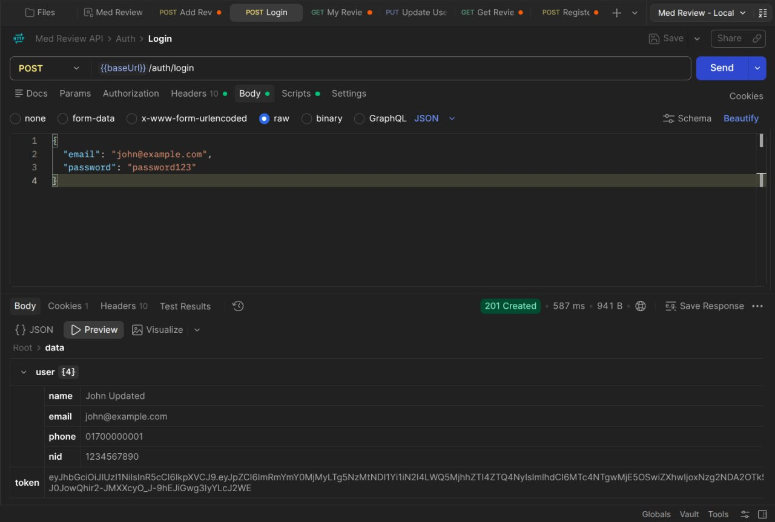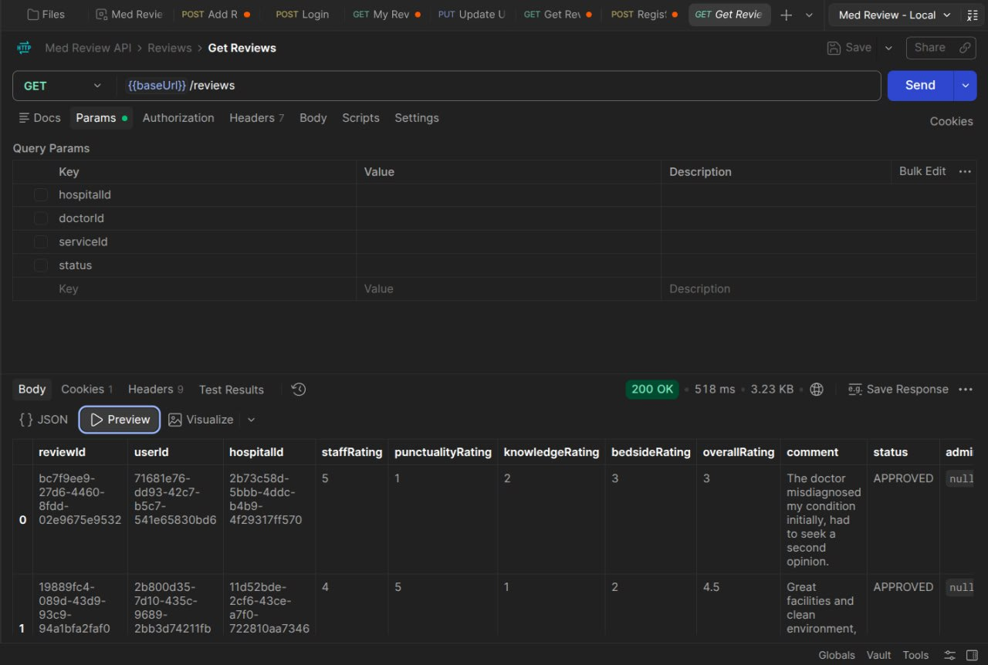
13. Data Analysis Potential
- Moderation Metrics: Tracking ratios of APPROVED vs. REJECTED reviews to quantify content credibility.
- Report Breakdown: Aggregating ReviewReport.reason entries to identify main sources of bad content (e.g., spam vs. HIPAA violations).
- Affiliation Insights: Mapping DoctorAffiliation patterns to evaluate practitioner distribution across healthcare facilities.
- Helpfulness Trends: Evaluating ReviewVote ratios to highlight reviews deemed most reliable by the patient community.
- Dimensional Performance: Comparing staff, punctuality, knowledge, and bedside manner scores to surface specific operational weaknesses in clinics.
14. Results
- Functional Authentication: Role-based JWT authentication and bcrypt password security fully implemented.
- Directory Management: Complete CRUD capabilities for Hospitals, Doctors, Specialties, and Medical Services.
- Verification Architecture: Review submission enforces mandatory proof attachment and defaults to PENDING.
- Admin Control: Functional moderation system allows admins to review proof, attach notes, and approve/reject feedback.
- Community Interactions: Helpfulness voting, reporting workflows, and user saved listings are operational.
15. Testing and Validation
TEST AREA | EXPECTED RESULT
Unique Voting Check | Duplicate votes by the same user on a single review are rejected.
Zod Input Validation | Invalid payload bodies or missing required sub-ratings return 400 Bad Request.
Role Authorization | Non-admin users attempting to access /api/admin/ receive 403 Forbidden.
Foreign Key Safety | Reviews targeting non-existent doctors or hospitals are rejected by database constraints.
Proof Enforceability | Review submission fails if no corresponding proof object is provided.

16. Challenges Encountered
- Multi-Target Relational Structure: Designing a flexible review schema capable of cleanly referencing doctors, hospitals, or services without breaking normalization.
- Dynamic Doctor Affiliations: Managing many-to-many linkages between doctors and hospitals while tracking primary workplaces.
- Data Privacy in Logs: Stripping sensitive information and masking IP addresses within audit logs.
- Sub-Rating Granularity: Balancing mandatory overall operational ratings with optional clinical sub-ratings.
17. Security and Data Integrity
- Password Hashing: All user passwords are encrypted using bcrypt prior to database storage.
- Stateless Authorization: Secure JWT access tokens validated on all protected endpoints.
- Request Validation: Strict runtime validation using Zod schemas before data touches controllers or database.
- Auditability: Sensitive operations and security events logged to SystemLog with masked IP addresses.
- Database Guardrails: Foreign keys, unique indexes, and enums enforce strict structural integrity.
18. Future Enhancements
- Automated Proof Verification: Integration of OCR to automatically read and verify uploaded medical bills or receipts.
- Interactive Frontend: Dedicated React/Next.js web and mobile applications interfacing with the API.
- Advanced Analytics Dashboard: Visual graphs and reporting suites for healthcare admins.
- Notification Engine: Instant email/SMS alerts notifying users when their review status is updated.
- Specialty & Location Search: Full-text search and geofenced filtering by proximity and specialty.
19. Conclusion
MedReview addresses healthcare review manipulation through a structured relational database backend that couples proof verification with multi-dimensional rating metrics. Built with Node.js, Express.js, Prisma, and PostgreSQL, the platform establishes referential integrity across 12 models while offering role-restricted administration, community engagement tools, and security auditing. The design provides a trustworthy platform for healthcare decision-making.

